Launch of UN Women’s Flagship Report
2019-2020

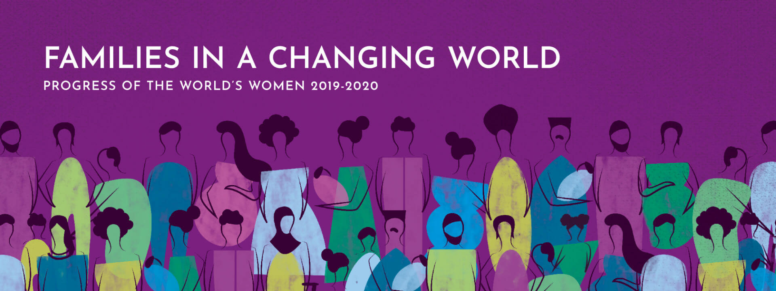

14 November 2019
Tbilisi

Venue: Radisson Blu hotel
Time: 09:30 – 12:00
Background
The Progress of the World’s Women report series, a periodic thematic investigation of women's rights, seeks to spur change in laws, policies and programmes, creating an enabling environment for women and girls to realize their rights. The recent UN Women progress reports have been conceptualized to inform acceleration towards achieving the 2030 Agenda, the world’s most comprehensive framework to ensure human progress, and its 17 Sustainable Development Goals (SDGs).
Based on research, evidence, innovative approaches and case studies, the 2019-2020 edition of the progress report takes a close look at families in a changing world. There is not (and has not been) any “standard” or “universal” form of a family; families are diverse and evolving. Globally, a little more than one third (38 per cent) of households are couples living with children; extended families (including other relatives) are almost as common (27 per cent); lone-parent families, the vast majority of which are led by women, account for 8 per cent of households; and in some countries, and in all regions, same-sex families are increasingly visible.
Families are places of care but can also bring conflict, inequality and violence. Today, 3 billion women and girls live in countries where rape within marriage is not explicitly criminalized; in one out of five countries, girls do not have the same inheritance rights as boys; in 19 countries, women are required by law to obey their husbands; and around one third of married women in developing countries report having little or no say over their own health care.
Women continue to enter the labour market in large numbers, but marriage and motherhood reduce their labour-force participation rates, as well as the income and benefits that come with it. Globally, just over half of married women aged 25-54 are in the labour force, compared to two thirds of single women and 96 per cent of married men, according to new data in the report. A major driver of these inequalities is the fact that women continue to do three times as much unpaid care and domestic work as men in the absence of affordable care services.
The report calls on policymakers, activists and people in all walks of life to transform families into places of equality and justice – where women can exercise choice and voice, and where they have physical safety and economic security. It also offers recommendations for policymakers to create an enabling environment for families and their members to thrive. An analysis produced for the report found that most countries could implement a package of policies, including lifetime income support, health care and care services for children and older persons, for less than 5 per cent of GDP.
Specific Focus of the Event

While the progress report covers numerous topics and offers a variety of findings to inform policy design and policymaking, the event will also specifically focus on the results of costing a package of family-friendly transfers and services. In addition to presenting the findings at the global and regional level, the presentation will also zoom in on the study results for Georgia, which can feed into discussions on the introduction of family-friendly policies in Georgia. This process in Georgia is one of the most discussed topics in the context of ongoing reforms related to the implementation of the Georgia/EU Association Agreement (Chapter 14: Employment, Social Policy and Equal Opportunities), as well as the 2030 Agenda and the achievement of nationalized SDGs (SDG 1 No Poverty, SDG 3 Good Health and Well-being, SDG 5 Gender Equality, SDG 8 Decent Work and Economic Growth and SDG 10 Reduced Inequalities).

Agenda and Speakers

09:00 – 09:30 | Registration and coffee
10:00 – 10:15 | Welcome speeches
Moderator:
- Erika Kvapilova, UN Women Country Representative in Georgia
Speakers:
- Represenetive of the Parliament of Georgia (Head of GE Council or Head of Social Committee, TBC)
- Deputy Minister of the Ministry of Internally Dislaced Persons, Labour, Health and Social Affairs of Georgia, Tamila Barkalaia (TBC)
- Advisor to the PM on Human Rights and Gender Equality Issues (to be appointed)
10:15 – 11:00 | National launch of UN Women Progress Report 2019-2020
10:15 – 11:00 | - Shahra Razavi, Chief of Research and Data, UN Women New York  - Q&A
11:00 – 12:00 | Family-friendly transfers and services: What will it cost?
11:00 – 12:00 | - Mira Bierbaum, JPO, Social Protection Department, ILO Geneva
12:00 – 13:30 | Lunch

Full report available at:
https://www.unwomen.org/-/media/headquarters/attachments/sections/library/publications/2019/progress-of-the-worlds-women-2019-2020-en.pdf?la=en&vs=3512

